Table of Contents

Model 2
deploy 2
Diagrama de contexto 3
Model diagram 3
Sistema app_Alex 4
Sistema app_Alex diagram 4
1

Model
Package in package ''

Model
Version Phase 1.0 Proposed
carpi created on 3/11/2025. Last modified 3/11/2025

deploy
Package in package 'Model'

deploy
Version 1.0 Phase 1.0 Proposed
carpi created on 3/11/2025. Last modified 3/11/2025

Model diagram
Deployment diagram in package 'deploy'

Model
Version 1.0
carpi created on 3/11/2025. Last modified 3/11/2025

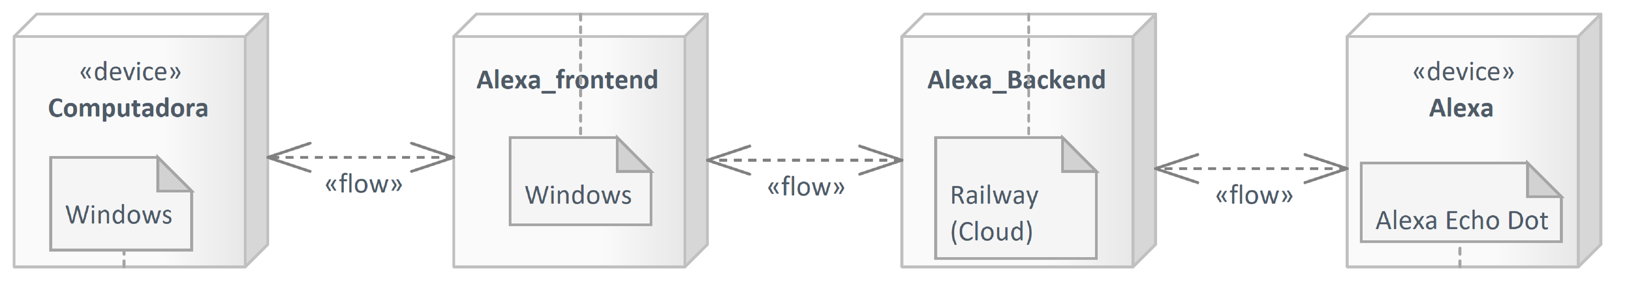

- Model

Diagrama de contexto
Package in package 'Model'

Diagrama de contexto
Version 1.0 Phase 1.0 Proposed
carpi created on 3/11/2025. Last modified 3/11/2025

Model diagram
Data Flow diagram in package 'Diagrama de contexto'

Model
Version 1.0
carpi created on 3/11/2025. Last modified 3/11/2025

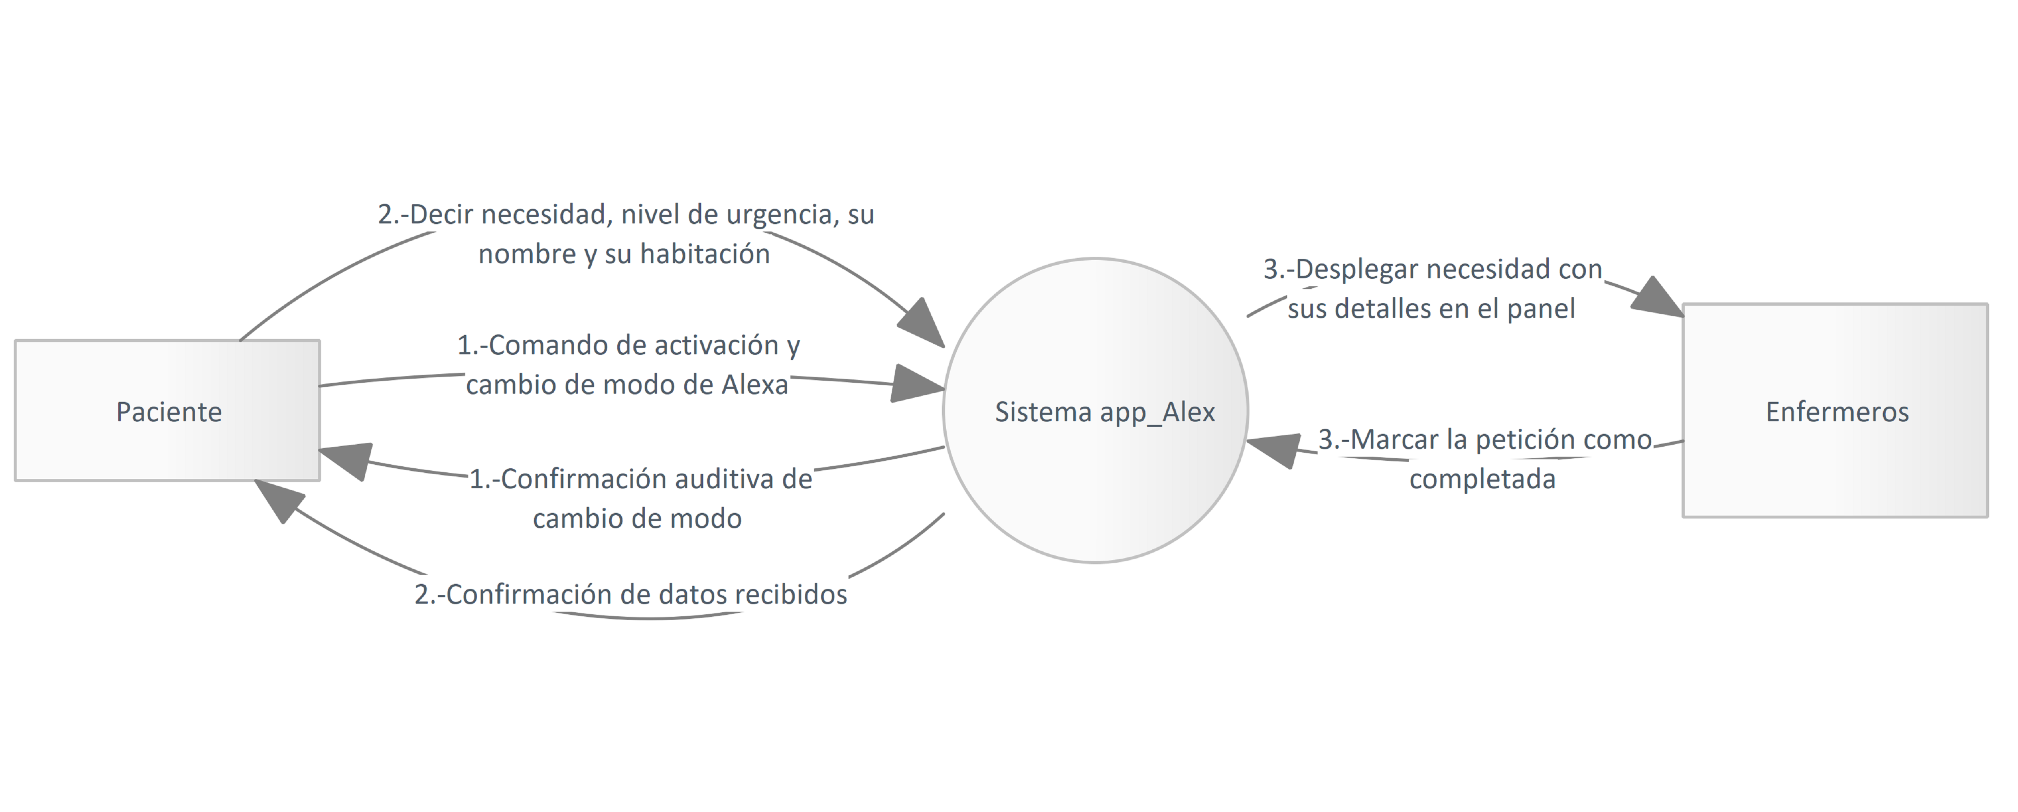

- Model

Sistema app_Alex diagram
Data Flow diagram in package 'Diagrama de contexto'

Sistema app_Alex
Version 1.0
carpi created on 3/11/2025. Last modified 3/11/2025

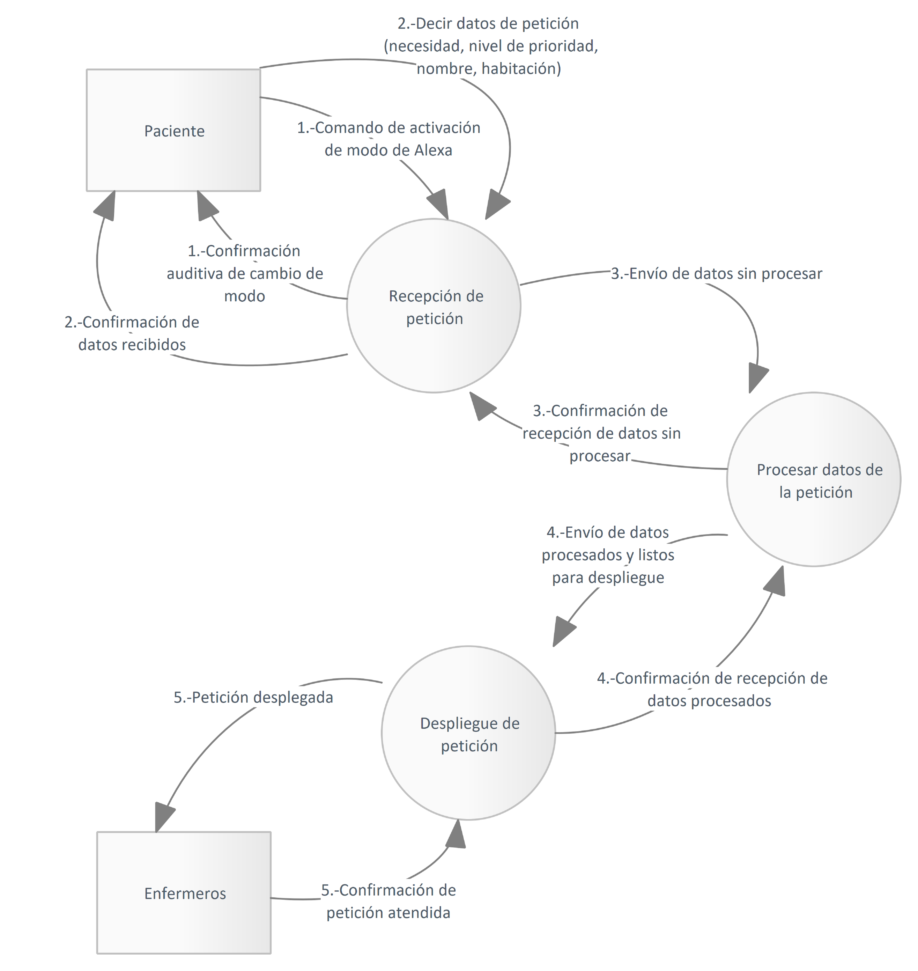

- Sistema app_Alex

